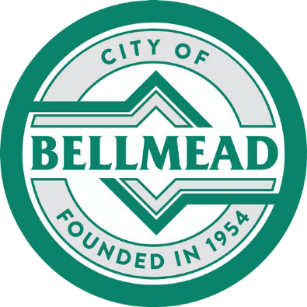
CITY OF BELLMEAD
PUBLIC NOTICE

Notice is hereby given that the City of Bellmead Planning and Zoning Commission and Bellmead City Council will conduct Public Hearings at Bellmead City Hall, 3015 Bellmead Dr., Bellmead, Texas on the following dates:

- Planning and Zoning Commission – August 19, 2025, at 6:30 PM
- City Council – September 9, 2025, at 6:30 PM

The Public Hearings are to consider the following request:
SPECIFIC USE PERMIT APPLICATION – 4301 Gram Lane FOR OPERATION OF A SHORT-TERM RENTAL BUSINESS UNIT.
The city of Bellmead is holding a hearing to provide the opportunity for community input and comment.
For questions or information regarding the requests, please contact Bellmead Community Development, 254-799-2436, ext. 6120 or fmorris@bellmeadtx.gov.

