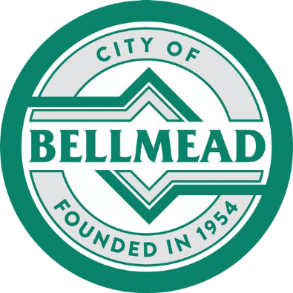
CITY OF BELLMEAD
PUBLIC NOTICE

Notice is hereby given that the City of Bellmead Planning and Zoning Commission and Bellmead City Council will conduct Public Hearings at Bellmead City Hall, 3015 Bellmead Dr., Bellmead, Texas, on the following dates:

- Planning and Zoning Commission Meeting – February 17, 2026, at 6:30 PM
- City Council Meeting – March 10, 2026, at 6:30 PM

The Public Hearings are to consider the following request:
CONSIDER AN ORDINANCE AMENDING THE CODE OF ORDINANCES, APPENDIX A-ZONING, TO REMOVE RESTRICTIONS ON FRONT YARD CARPORTS IN R-1, R-1A, AND R-2 ZONING DISTRICTS.
The city of Bellmead is holding a public hearing to provide the opportunity for community input and comment.
For questions or information regarding the requests, please contact the Bellmead Community Development Director at 254-799-2436, ext. 6120, or fmorris@bellmeadtx.gov.

